**EXCEL NOTES YOUTUBE LUKE BAROUSSE**

1. When we enter TRUE or False as the data in a cell it takes that as a Boolean value and centers the text making it all capital.

2. When we wish to concatenate 2 texts or numbers together we can use ( & ).

Cell select & cell select – output is the text in the 2 cells concatenated

If we wish to add any kind of spaces in between the

Cell select & “ “ & cell select - this gives the data with the space between the 2 cells.

3. Ranges - when we need to work on a particular set of data we just select a cell type ( = ) and then go on to select the range and this gives us the desired range of our data. This is only available in the latest versions of excel and the older versions cannot detect this formula and shows error.

4. TO COPY ONE WORKSHHET TO ANOTHER WORK BOOK

a. select the range of cells from the data and then paste it to the desired workbook

b. in the new workbook press = and then select the range in the original worksheet and then press enter.

c. in the original workbook , right click on the sheet below corner and press move, then select the work book , select create copy and then enter, to move a copy of the sheet to the workbook.

5. When we need to sort a data we select the first column of the data and select the filter on the right corner, this provides us with drop down menu that then allows us for sorting the data accordingly.

6. When we need to make a chart for the given data , we select the range of cells and then go to insert menu and click on recommended charts and then click on the desired charts.

It also provides us with a pivot table that can be used further to manipulate the data.

7. When we want to freeze the first column and the row, we go on to the view tab, then select the cell above which and beside which we want the row and the column to be fixed and click on freeze panes. This fixes the first row and column and the rest goes on scrolling.

8. 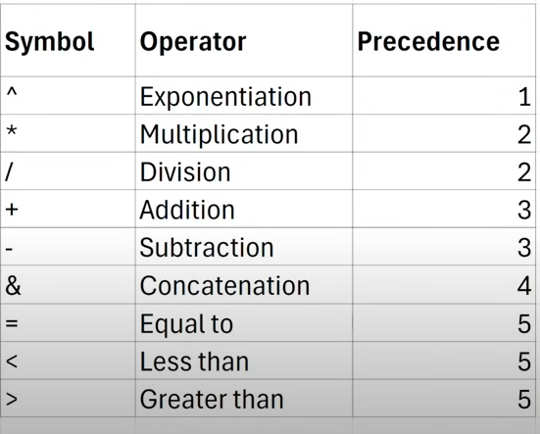

9. 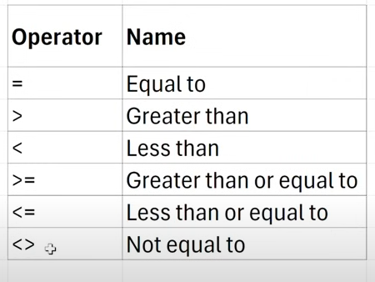

10. When we drag in to apply the same operation over a number of columns then we apply a dollar sign on the row and column number of the cells in the formula bar, that is called fixed reference (when applied for both row and col) , when it is applied for either row or col. ( mixed reference). We can use ( Fn + f4) for directly applying this cell reference.

11. Using the formulas is always preferred as when we make any changes in the reference cell in future then it updates automatically.

12. TRUE is stored as 1 and FALSE is stored as 0 by excel.

13. IF(criteria, what if true, what if false) – Here in IF statement , you give a criteria or logic and that if it is true then the first statement is displayed or computed, else the false part.

You can also do Nested IF , in some cases but not preferred, like in the false or true place can put another IF statement.

14. Incase if we miss out of some data and still want to iterate through the IF statement then what we do is use IFS(logical, if true, logical, if true……) and this can be used in such cases.

13.When we are operating on certain logical functions that include having a cell reference then we see that we cannot put the reference with the operator, so in that case what we do is that we add the operator in double quotes as a string and then put & and then the cell reference that concatenates and considers the value.